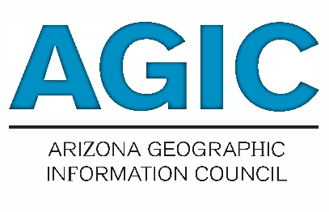 | 911 Committee  2021 Work Plan

Mission (from statutes):
- Provide a forum to promote and support interagency coordination on matters related to 9-1-1 geospatial data, data sharing, and applications.
- Facilitate 9-1-1 educational outreach and best practice methods to state, federal and local government agencies in order to support an State-wide Arizona 9-1-1 Next Generation system

2021 Meeting Dates:
911 Committee Meetings | January | April | July | October
Council Meetings | February | May | August | November

911 Committee Participants:
Chairs: Brian Bond & Surprise it could be you?
Voting Members:
Public at Large: You!

Goals and Activities: {help is needed here}
- Build Collaboration of work for State-wide 911 data
  - Foster cooperation among neighboring 9-1-1 Systems to build a seamless state-wide data.
  - Facilitated creation of 9-1-1 data sharing agreements.
  - Facilitate individual 9-1-1 system work flows to be concrete.
  - Identify under-served communities without the resources to complete GIS data for spatial routing.
    - Quantify the underserved areas without GIS support. Outreach committee may also be doing some things about this. Build supporting documentation.
  - {help is needed here}

- Facilitate GIS related ... {help is needed here}
  - Support current and Next Generation 9-1-1 (NG9-1-1) geospatial data, initiatives, and technologies.
  - Support 9-1-1 System Administrators and GIS professionals in the creation of agency work flow plans to define NG9-1-1 GIS data procedures in support of spatial routing and public safety GIS needs.
    - As an example, data procedures in support of spatial routing, the AZGIV application GIS data validation tool, and Quality Control/Quality Assurance efforts.
  - Facilitate the statewide needs for 9-1-1 GIS data layers, applications, and coordination.
  - Facilitate the adoption of authoritative data sets to support 9-1-1 and government solutions.
  - Coordinate with other AGIC Committees to carry out proposed activities.

- Facilitate education for support 9-1-1 systems to keep in line with national recommended guidelines in both GIS and PSAP organization.
  - Serve as a forum for informational exchange of standards, changes, and other related to a 9-1-1 system for federal, state, tribal, regional, and local governments, the private sector, and professional associations.
  - Coordinate as needed with other AGIC Committees to carry out proposed activities.

