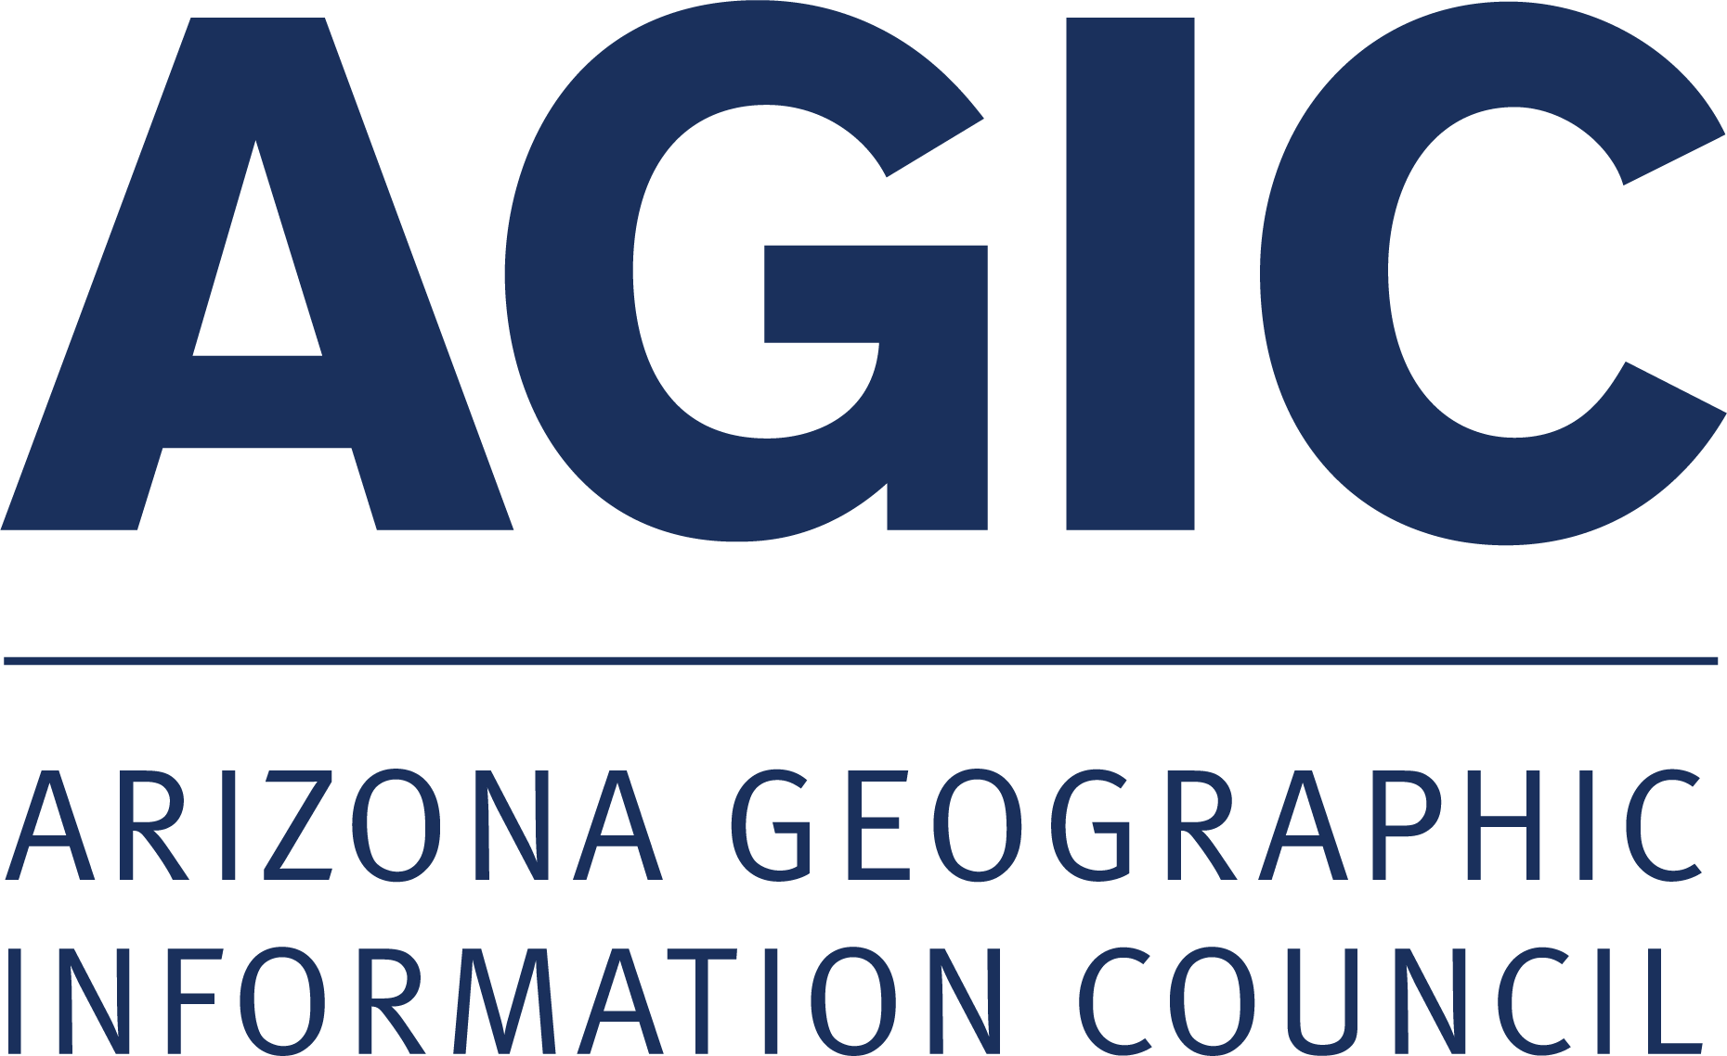 | AZGeo Advisory Committee  2022-2023 Work Plan

Mission (from statutes):
- Collaborate to ensure the sustainability of the state geospatial clearinghouse, AZGeo, as a central repository for geospatial data and statewide geographic information system services
- Facilitate the advancement of AZGeo to enhance and support state, federal, and local government business systems
- Incorporate user requirements on matters related to geospatial data, services, standards, applications, and activities to improve data sharing and use

2022 Meeting Dates:
- This group intends to meet on the third Tuesday of every other month from 11:00 am -12:00 pm

AZGeo Advisory Committee Members/Participants (by last name):
- Voting Members:
  - ASLD Representative: Ryan Johnson, Co-chair
  - AGIC Chair: Eric Shreve, Co-chair (ADOA)
  - AGIC Vice-Chair: Kevin Blake (Yavapai County)
  - Outreach Committee Representative: Patrick Whiteford (ADOT)
  - Data Committee Representative: Howard Ward (TerraSystems SW)
- Required Non-voting members: Kasey Green (AZGeo Data Curator), Ayan Mitra (AZGeo Contracted Developer)
- Public at Large Participants (identified by attending one of the previous three meetings): Jack Avis, Brandon Barnett, Wolfgang Grunberg, Bo Guo, Shea Lemar, Jenna Leveille, Seth Lewis, James Meyer, Mariah Modson, Mike Walck, Steve Whitney
Goals And Activities
Provide a forum for information exchange to facilitate the advancement and sustainability of AZGeo as the state geospatial clearinghouse
- Continue to secure resources for sustainable and long-term maintenance of AZGeo and curation of its content
- Assess opportunities to expand and improve AZGeo continuity and functionality
- Collect and assess feedback from the AZGeo User community
- Coordinate and support two user group meetings per year.
Facilitate the development of best practices, data standards, and specifications for AZGeo contributors
- Coordinate and collaborate with local, regional, tribal, and state organizations and AGIC Committees to develop recommendations for best practices and data governance associated to AZGeo
- Document and share outcomes for best practices with the AZGeo User Community
Facilitate Interagency Coordination and Encourage Geospatial Data Sharing utilizing AZGeo
- Serve as a forum to facilitate informational exchange between AZ public universities, state, federal, tribal, regional, and local governments, the private sector and professional associations.

