A Public meeting of the Arizona Geographic Information Council (AGIC) was convened on Tuesday, February 11th via Google Meet. Present at the meeting were the following members or designees of the AGIC Natural Resources Committee:

|  |  |  |  |
| --- | --- | --- | --- |
| **Table 1: Committee Voting Members** | | | |
| **Member** | | **Agency/Company** | **In Attendance** |
| Elisabeth vanderLeeuw, Co-chair | | Pima County | Yes, phone |
| Andy Weflen, Co-chair | | Maricopa County | Yes, phone |
| Karen Fisher, Co-chair | | Central Arizona Project | Yes, phone |
| Aryn Musgrave, Secretary | | Desert Botanical Garden | Yes, phone |
| Robert Davis | | Arizona GIS | Yes, phone |
| Jami Dennis | | Geodetic Analysis | Yes, phone |
| Jenna Leveille | | Sanborn | No |
| Ben Hickson | | Anderson Optimization | No |
| Tanya Owens | | Westland Resources | Yes, phone |
| Jatta Sheehy | | TerraSystems Southwest | No |
| **Table 2: Public at Large** | | | |
| **Member** | **Agency/Company** | | **In Attendance** |
| Cynthia Ritmiller | USGS | | Yes, phone |
| Lucas Murray | ADOT | | Yes, phone |
| Robert Davis |  | |  |
| Rob Hastings | Pima County ITD/GIS | | Yes, phone |
| Shea Lemar | ASLD | | Yes, phone |
| Shiloh Johnson | Maricopa County ETI | | Yes, phone |
| Keith Larson | USDA-NRCS | | Yes, phone |
| Lissa Klun | ADEQ | | Yes, phone |
| Meghan LaPointe | Legacy Works Group | | Yes, phone |
| Sage Donaldson | ADOT | | Yes, phone |
| Alene McCracken | ADWR | | Yes, phone |
| Andrew Hagglund | Entellus | | Yes, phone |
| Cody Maynard | ADEQ | | Yes, phone |
| Garrett Smith | University of Arizona | | Yes, phone |
| Jim Downey | DFFM | | Yes, phone |
| Jeff Gillan | University of Arizona/Gillan Geospatial LLC | | Yes, phone |
| Josh Sutter | Maricopa County | | Yes, phone |

# Call to Order:

Meeting was called to order at 2:01pm; Introductions were made by the committee; ensuring attendance list was managed and quorum established.

# Approval of Meeting Minutes: (1:35)

A motion to approve October meeting minutes was made by Robert Davis and seconded by Karen Fisher. There was no discussion and the meeting minutes were unanimously approved.

# Announcements: (3:00)

Andy Weflen gave a report on the state of the AGIC Mentorship Program. Shea Lemar gave a quick update on the objectives of the other committees.

IV. **Spring Event Planning:** **(14:00)**

Karen and Andrew reported that they are still looking for a place to host the spring “fly-in” event in coordination with the Emerging Technologies Workgroup. It is likely to be hosted in Phoenix instead of at Yavapai Community College this year.

V. **Presentation: Monitoring Stinknet** (Joshua Sutter) **(18:00)**

A case study for using GIS and drone technologies to monitor and control invasive plant species in Phoenix.

# Protected Areas Database Work Group (Elisabeth Vander Leeuw): (51:00)

Elisabeth asked for a volunteer to help organize the next meeting and recruit a few more people to help complete the project.

# Hub Site Updates Work Group (Wolfgang Grunberg): (54:00)

No updates presented at this meeting. Wolfgang will present at the next meeting.

# Mobile GIS workgroup (Robert Davis) (56:00)

Andy proposed discussing the creation of a Mobile GIS Workgroup and Karen made a motion to begin this discussion, Elisabeth seconded this motion.

# USGS Update (1:04:00)

**3DHP Updates (**[https://www.usgs.gov/3dhp/about](https://nam11.safelinks.protection.outlook.com/?url=https%3A%2F%2Fwww.usgs.gov%2F3dhp%2Fabout&data=05%7C02%7Camusgrave%40dbg.org%7C352b3a58d2734a968fff08dd4ae88898%7Cb2253bf7be0c4b33aebd3d97aa0cbfb7%7C0%7C0%7C638749084799994354%7CUnknown%7CTWFpbGZsb3d8eyJFbXB0eU1hcGkiOnRydWUsIlYiOiIwLjAuMDAwMCIsIlAiOiJXaW4zMiIsIkFOIjoiTWFpbCIsIldUIjoyfQ%3D%3D%7C0%7C%7C%7C&sdata=Hc%2BRPB2yGjGej3WsAxM%2ByrYJljXYnefi30dpDot035E%3D&reserved=0))**:**

Differences between the EDH and 3DHP datasets has been added to the 3DHP DCA Appendix H or from the following website ([https://www.usgs.gov/3DHP/differences-between-edh-and-3dhp-data](https://nam11.safelinks.protection.outlook.com/?url=https%3A%2F%2Fwww.usgs.gov%2F3DHP%2Fdifferences-between-edh-and-3dhp-data&data=05%7C02%7Camusgrave%40dbg.org%7C352b3a58d2734a968fff08dd4ae88898%7Cb2253bf7be0c4b33aebd3d97aa0cbfb7%7C0%7C0%7C638749084800011117%7CUnknown%7CTWFpbGZsb3d8eyJFbXB0eU1hcGkiOnRydWUsIlYiOiIwLjAuMDAwMCIsIlAiOiJXaW4zMiIsIkFOIjoiTWFpbCIsIldUIjoyfQ%3D%3D%7C0%7C%7C%7C&sdata=%2FdKPRYVd6VQR6edjPiHz9wdvF6fFHI66ur60xqiibaw%3D&reserved=0)).

**USGS Hydrography Community Call**

Starting January 2025, the USGS Hydrography Community Call will be scheduled quarterly on the fourth Tuesday of the month at 1:00 PM EST. Subscribe to the calls and find links to recordings of the calls on the [Hydrography Community Call (https://www.usgs.gov/3d-hydrography-program/hydrography-community-calls)](Hydrography%20Community%20Call%20(https:/www.usgs.gov/3d-hydrography-program/hydrography-community-calls)) website.

**3DEP/Lidar Updates:**

1. AZ_Mohave_D23 has passed validation and will be published shortly.
2. AZ_Lower ColoradoTB1_C23  topobathy data of Colorado River starting at Lake Mead all the way to Mexico has been published.
3. AZ_Eastern_D24 data has been acquired and is in work by the contractor.
4. Grand Canyon project is moving along with anticipated acquisition summer 2025.

**Other Updates:**

* USGS has updates to the TNM- 3D Viewer   [https://apps.nationalmap.gov/viewer-3D-beta/](https://nam11.safelinks.protection.outlook.com/?url=https%3A%2F%2Fapps.nationalmap.gov%2Fviewer-3D-beta%2F&data=05%7C02%7Camusgrave%40dbg.org%7C352b3a58d2734a968fff08dd4ae88898%7Cb2253bf7be0c4b33aebd3d97aa0cbfb7%7C0%7C0%7C638749084800025803%7CUnknown%7CTWFpbGZsb3d8eyJFbXB0eU1hcGkiOnRydWUsIlYiOiIwLjAuMDAwMCIsIlAiOiJXaW4zMiIsIkFOIjoiTWFpbCIsIldUIjoyfQ%3D%3D%7C0%7C%7C%7C&sdata=41C4xYmpbfXmzNg8KrTlJPJDQEeBuaqqObDr81pTtgQ%3D&reserved=0)
* National Digital Trails Newsletter [https://www.usgs.gov/national-digital-trails-newsletter/national-digital-trails-project-highlights-2024](https://nam11.safelinks.protection.outlook.com/?url=https%3A%2F%2Fwww.usgs.gov%2Fnational-digital-trails-newsletter%2Fnational-digital-trails-project-highlights-2024&data=05%7C02%7Camusgrave%40dbg.org%7C352b3a58d2734a968fff08dd4ae88898%7Cb2253bf7be0c4b33aebd3d97aa0cbfb7%7C0%7C0%7C638749084800040648%7CUnknown%7CTWFpbGZsb3d8eyJFbXB0eU1hcGkiOnRydWUsIlYiOiIwLjAuMDAwMCIsIlAiOiJXaW4zMiIsIkFOIjoiTWFpbCIsIldUIjoyfQ%3D%3D%7C0%7C%7C%7C&sdata=clqP6jWq5sLyPM8J%2FiFDhJpfZvAyDpX%2BpX6pd5JqaeQ%3D&reserved=0)

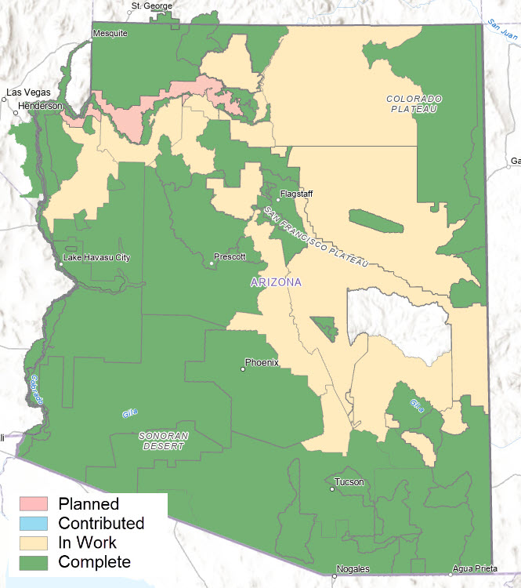

# Future topics: (1:17:00)

Andy asked the group to share any interesting topics or presentation ideas to provide content for future meetings. Shea suggested a presentation on National Digital Trails and asked the group to put ideas into the chat about topics that they would like to learn more about. Some of the topics commented by the group included Desert Defenders projects, wildfire management, work done by the Sky Island Alliance on borderland studies, the use of LiDAR and hyperspectral data in the use of monitoring native grasses.

1. **Adjourn: (1:28:00)**

The meeting was adjourned at 3:30pm. The next meeting will be held on April 8th, 2025.